# 

# **Q) What is artificial intelligence? Explain the four definitions of Artificial intelligence?**

**1. Acting humanly:** When a computer acts like a human, it best reflects the Turing test, in which the computer succeeds when [differentiation between the computer and a human](http://www.turing.org.uk/scrapbook/test.html) isn’t possible. This category also reflects what the media would have you believe AI is all about. You see it employed for technologies such as natural language processing, knowledge representation, automated reasoning, and machine learning (all four of which must be present to pass the test

The original Turing Test didn’t include any physical contact. The newer, Total Turing Test does include physical contact in the form of perceptual ability interrogation, which means that the computer must also employ both computer vision and robotics to succeed. Modern techniques include the idea of achieving the goal rather than mimicking humans completely. For example, the Wright Brothers didn’t succeed in creating an airplane by precisely copying the flight of birds; rather, the birds provided ideas that led to aerodynamics that eventually led to human flight. The goal is to fly. Both birds and humans achieve this goal, but they use different approaches.

**2. Thinking humanly:** When a computer thinks as a human, it performs tasks that require intelligence (as contrasted with rote procedures) from a human to succeed, such as driving a car. To determine whether a program thinks like a human, you must have some method of determining how humans think, which the cognitive modeling approach defines. This model relies on three techniques:

**Introspection:** Detecting and documenting the techniques used to achieve goals by monitoring one’s own thought processes.

**Psychological testing:** Observing a person’s behavior and adding it to a database of similar behaviors from other persons given a similar set of circumstances, goals, resources, and environmental conditions (among other things).

**Brain imaging:** Monitoring brain activity directly through various mechanical means, such as Computerized Axial Tomography (CAT), Positron Emission Tomography (PET), Magnetic Resonance Imaging (MRI), and Magnetoencephalography (MEG).

After creating a model, you can write a program that simulates the model. Given the amount of variability among human thought processes and the difficulty of accurately representing these thought processes as part of a program, the results are experimental at best. This category of thinking humanly is often used in psychology and other fields in which modeling the human thought process to create realistic simulations is essential.

**3. Thinking rationally:** Studying how humans think using some standard enables the creation of guidelines that describe typical human behaviors. A person is considered rational when following these behaviors within certain levels of deviation. A computer that thinks rationally relies on the recorded behaviors to create a guide as to how to interact with an environment based on the data at hand. The goal of this approach is to solve problems logically, when possible. In many cases, this approach would enable the creation of a baseline technique for solving a problem, which would then be modified to actually solve the problem. In other words, the solving of a problem in principle is often different from solving it in practice, but you still need a starting point.

**4. Acting rationally:** Studying how humans act in given situations under specific constraints enables you to determine which techniques are both efficient and effective. A computer that acts rationally relies on the recorded actions to interact with an environment based on conditions, environmental factors, and existing data. As with rational thought, rational acts depend on a solution in principle, which may not prove useful in practice. However, rational acts do provide a baseline upon which a computer can begin negotiating the successful completion of a goal.

The categories used to define AI offer a way to consider various uses for or ways to apply AI. Some of the systems used to classify AI by type are arbitrary and not distinct. For example, some groups view AI as either strong (generalized intelligence that can adapt to a variety of situations) or weak (specific intelligence designed to perform a particular task well). The problem with strong AI is that it doesn’t perform any task well, while weak AI is too specific to perform tasks independently. Even so, just two type classifications won’t do the job even in a general sense. The four classification types promoted by [Arend Hintze](http://theconversation.com/understanding-the-four-types-of-ai-from-reactive-robots-to-self-aware-beings-67616) form a better basis for understanding AI:

**Reactive machines:** The machines you see beating humans at chess or playing on game shows are examples of reactive machines. A reactive machine has no memory or experience upon which to base a decision. Instead, it relies on pure computational power and smart algorithms to recreate every decision every time. This is an example of a weak AI used for a specific purpose.

**Limited memory:** A self-driving car or autonomous robot can’t afford the time to make every decision from scratch. These machines rely on a small amount of memory to provide experiential knowledge of various situations. When the machine sees the same situation, it can rely on experience to reduce reaction time and to provide more resources for making new decisions that haven’t yet been made. This is an example of the current level of strong AI.

**Theory of mind:** A machine that can assess both its required goals and the potential goals of other entities in the same environment has a kind of understanding that is feasible to some extent today, but not in any commercial form. However, for self-driving cars to become truly autonomous, this level of AI must be fully developed. A self-driving car would not only need to know that it must go from one point to another, but also intuit the potentially conflicting goals of drivers around it and react accordingly.

**Self-awareness:** This is the sort of AI that you see in movies. However, it requires technologies that aren’t even remotely possible now because such a machine would have a sense of both self and consciousness. In addition, instead of merely intuiting the goals of others based on environment and other entity reactions, this type of machine would be able to infer the intent of others based on experiential knowledge.

# **Q) What are the applications of Artificial Intelligence?**

# **Application of AI**

Artificial Intelligence has various applications in today's society. It is becoming essential for today's time because it can solve complex problems with an efficient way in multiple industries, such as Healthcare, entertainment, finance, education, etc. AI is making our daily life more comfortable and fast.

Following are some sectors which have the application of Artificial Intelligence:

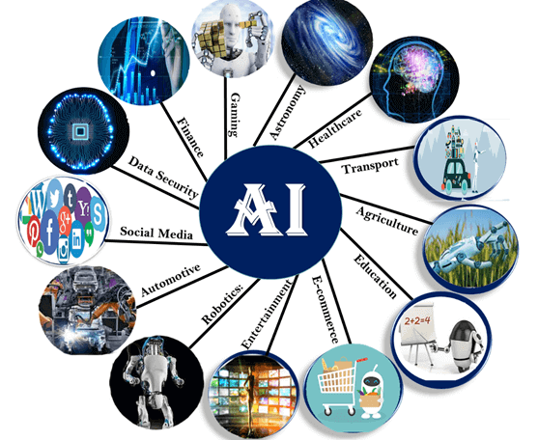

### 1. AI in Astronomy

* Artificial Intelligence can be very useful to solve complex universe problems. AI technology can be helpful for understanding the universe such as how it works, origin, etc.

### 2. AI in Healthcare

* In the last, five to ten years, AI becoming more advantageous for the healthcare industry and going to have a significant impact on this industry.
* Healthcare Industries are applying AI to make a better and faster diagnosis than humans. AI can help doctors with diagnoses and can inform when patients are worsening so that medical help can reach to the patient before hospitalization.

### 3. AI in Gaming

* AI can be used for gaming purpose. The AI machines can play strategic games like chess, where the machine needs to think of a large number of possible places.

### 4. AI in Finance

* AI and finance industries are the best matches for each other. The finance industry is implementing automation, chatbot, adaptive intelligence, algorithm trading, and machine learning into financial processes.

### 5. AI in Data Security

* The security of data is crucial for every company and cyber-attacks are growing very rapidly in the digital world. AI can be used to make your data more safe and secure. Some examples such as AEG bot, AI2 Platform,are used to determine software bug and cyber-attacks in a better way.

### 6. AI in Social Media

* Social Media sites such as Facebook, Twitter, and Snapchat contain billions of user profiles, which need to be stored and managed in a very efficient way. AI can organize and manage massive amounts of data. AI can analyze lots of data to identify the latest trends, hashtag, and requirement of different users.

### 7. AI in Travel & Transport

* AI is becoming highly demanding for travel industries. AI is capable of doing various travel related works such as from making travel arrangement to suggesting the hotels, flights, and best routes to the customers. Travel industries are using AI-powered chatbots which can make human-like interaction with customers for better and fast response.

### 8. AI in Automotive Industry

* Some Automotive industries are using AI to provide virtual assistant to their user for better performance. Such as Tesla has introduced TeslaBot, an intelligent virtual assistant.
* Various Industries are currently working for developing self-driven cars which can make your journey more safe and secure.

### 9. AI in Robotics:

* Artificial Intelligence has a remarkable role in Robotics. Usually, general robots are programmed such that they can perform some repetitive task, but with the help of AI, we can create intelligent robots which can perform tasks with their own experiences without pre-programmed.
* Humanoid Robots are best examples for AI in robotics, recently the intelligent Humanoid robot named as Erica and Sophia has been developed which can talk and behave like humans.

### 10. AI in Entertainment

* We are currently using some AI based applications in our daily life with some entertainment services such as Netflix or Amazon. With the help of ML/AI algorithms, these services show the recommendations for programs or shows.

### 11. AI in Agriculture

* Agriculture is an area which requires various resources, labor, money, and time for best result. Now a day's agriculture is becoming digital, and AI is emerging in this field. Agriculture is applying AI as agriculture robotics, solid and crop monitoring, predictive analysis. AI in agriculture can be very helpful for farmers.

### 12. AI in E-commerce

* AI is providing a competitive edge to the e-commerce industry, and it is becoming more demanding in the e-commerce business. AI is helping shoppers to discover associated products with recommended size, color, or even brand.

### 13. AI in education:

* AI can automate grading so that the tutor can have more time to teach. AI chatbot can communicate with students as a teaching assistant.
* AI in the future can be work as a personal virtual tutor for students, which will be accessible easily at any time and any place.

# **Q) Explain the history of Artificial Intelligence?**

# History of Artificial Intelligence

Artificial Intelligence is not a new word and not a new technology for researchers. This technology is much older than you would imagine. Even there are the myths of Mechanical men in Ancient Greek and Egyptian Myths. Following are some milestones in the history of AI which defines the journey from the AI generation to till date development.

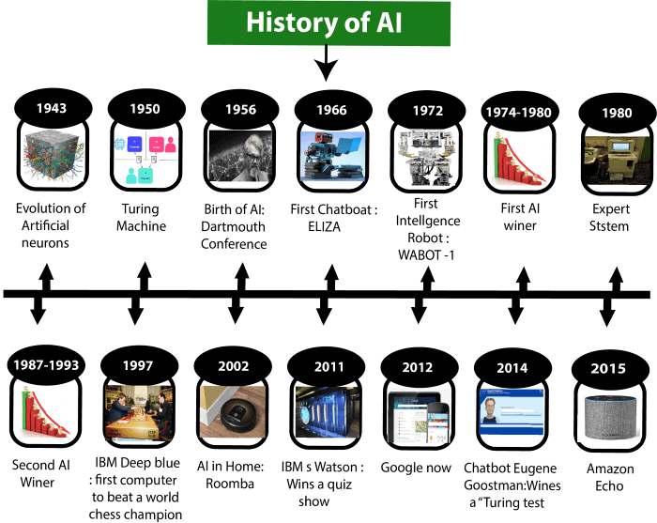

## 

## 

## Maturation of Artificial Intelligence (1943-1952)

* **Year 1943:** The first work which is now recognized as AI was done by Warren McCulloch and Walter pits in 1943. They proposed a model of **artificial neurons**.
* **Year 1949:** Donald Hebb demonstrated an updating rule for modifying the connection strength between neurons. His rule is now called **Hebbian learning**.
* **Year 1950:** The Alan Turing who was an English mathematician and pioneered Machine learning in 1950. Alan Turing publishes **"Computing Machinery and Intelligence"** in which he proposed a test. The test can check the machine's ability to exhibit intelligent behavior equivalent to human intelligence, called a **Turing test**.

## The birth of Artificial Intelligence (1952-1956)

* **Year 1955:** An Allen Newell and Herbert A. Simon created the "first artificial intelligence program"Which was named as **"Logic Theorist"**. This program had proved 38 of 52 Mathematics theorems, and find new and more elegant proofs for some theorems.
* **Year 1956:** The word "Artificial Intelligence" first adopted by American Computer scientist John McCarthy at the Dartmouth Conference. For the first time, AI coined as an academic field.

At that time high-level computer languages such as FORTRAN, LISP, or COBOL were invented. And the enthusiasm for AI was very high at that time.

## 

## 

## The golden years-Early enthusiasm (1956-1974)

* **Year 1966:** The researchers emphasized developing algorithms which can solve mathematical problems. Joseph Weizenbaum created the first chatbot in 1966, which was named as ELIZA.
* **Year 1972:** The first intelligent humanoid robot was built in Japan which was named as WABOT-1.

## The first AI winter (1974-1980)

* The duration between years 1974 to 1980 was the first AI winter duration. AI winter refers to the time period where computer scientist dealt with a severe shortage of funding from government for AI researches.
* During AI winters, an interest of publicity on artificial intelligence was decreased.

## A boom of AI (1980-1987)

* **Year 1980:** After AI winter duration, AI came back with "Expert System". Expert systems were programmed that emulate the decision-making ability of a human expert.
* In the Year 1980, the first national conference of the American Association of Artificial Intelligence **was held at Stanford University**.

## The second AI winter (1987-1993)

* The duration between the years 1987 to 1993 was the second AI Winter duration.
* Again Investors and government stopped in funding for AI research as due to high cost but not efficient result. The expert system such as XCON was very cost effective.

## The emergence of intelligent agents (1993-2011)

* **Year 1997:** In the year 1997, IBM Deep Blue beats world chess champion, Gary Kasparov, and became the first computer to beat a world chess champion.
* **Year 2002:** for the first time, AI entered the home in the form of Roomba, a vacuum cleaner.
* **Year 2006:** AI came in the Business world till the year 2006. Companies like Facebook, Twitter, and Netflix also started using AI.

## Deep learning, big data and artificial general intelligence (2011-present)

* **Year 2011:** In the year 2011, IBM's Watson won jeopardy, a quiz show, where it had to solve the complex questions as well as riddles. Watson had proved that it could understand natural language and can solve tricky questions quickly.
* **Year 2012:** Google has launched an Android app feature "Google now", which was able to provide information to the user as a prediction.
* **Year 2014:** In the year 2014, Chatbot "Eugene Goostman" won a competition in the infamous "Turing test."
* **Year 2018:** The "Project Debater" from IBM debated on complex topics with two master debaters and also performed extremely well.
* Google has demonstrated an AI program "Duplex" which was a virtual assistant and which had taken hairdresser appointment on call, and lady on other side didn't notice that she was talking with the machine.

Now AI has developed to a remarkable level. The concept of Deep learning, big data, and data science are now trending like a boom. Nowadays companies like Google, Facebook, IBM, and Amazon are working with AI and creating amazing devices. The future of Artificial Intelligence is inspiring and will come with high intelligence.

**Q) Explain different types of AI?**

Different types of AI

# Types of Artificial Intelligence:

Artificial Intelligence can be divided in various types, there are mainly two types of main categorization which are based on capabilities and based on functionally of AI. Following is flow diagram which explain the types of AI.

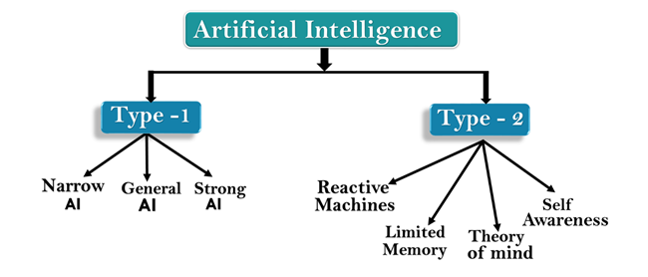

## AI type-1: Based on Capabilities

### 1. Weak AI or Narrow AI:

* Narrow AI is a type of AI which is able to perform a dedicated task with intelligence.The most common and currently available AI is Narrow AI in the world of Artificial Intelligence.
* Narrow AI cannot perform beyond its field or limitations, as it is only trained for one specific task. Hence it is also termed as weak AI. Narrow AI can fail in unpredictable ways if it goes beyond its limits.
* Apple Siriis a good example of Narrow AI, but it operates with a limited pre-defined range of functions.
* IBM's Watson supercomputer also comes under Narrow AI, as it uses an Expert system approach combined with Machine learning and natural language processing.
* Some Examples of Narrow AI are playing chess, purchasing suggestions on e-commerce site, self-driving cars, speech recognition, and image recognition.

### 2. General AI:

* General AI is a type of intelligence which could perform any intellectual task with efficiency like a human.
* The idea behind the general AI to make such a system which could be smarter and think like a human by its own.
* Currently, there is no such system exist which could come under general AI and can perform any task as perfect as a human.
* The worldwide researchers are now focused on developing machines with General AI.
* As systems with general AI are still under research, and it will take lots of efforts and time to develop such systems.

### 3. Super AI:

* Super AI is a level of Intelligence of Systems at which machines could surpass human intelligence, and can perform any task better than human with cognitive properties. It is an outcome of general AI.
* Some key characteristics of strong AI include capability include the ability to think, to reason,solve the puzzle, make judgments, plan, learn, and communicate by its own.
* Super AI is still a hypothetical concept of Artificial Intelligence. Development of such systems in real is still world changing task.

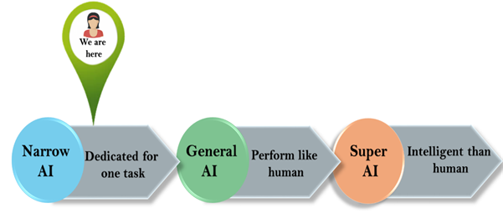

## Artificial Intelligence type-2: Based on functionality

### 1. Reactive Machines

* Purely reactive machines are the most basic types of Artificial Intelligence.
* Such AI systems do not store memories or past experiences for future actions.
* These machines only focus on current scenarios and react on it as per possible best action.
* IBM's Deep Blue system is an example of reactive machines.
* Google's AlphaGo is also an example of reactive machines.

### 2. Limited Memory

* Limited memory machines can store past experiences or some data for a short period of time.
* These machines can use stored data for a limited time period only.
* Self-driving cars are one of the best examples of Limited Memory systems. These cars can store recent speed of nearby cars, the distance of other cars, speed limit, and other information to navigate the road.

### 3. Theory of Mind

* Theory of Mind AI should understand the human emotions, people, beliefs, and be able to interact socially like humans.
* This type of AI machines are still not developed, but researchers are making lots of efforts and improvement for developing such AI machines.

### 4. Self-Awareness

* Self-awareness AI is the future of Artificial Intelligence. These machines will be super intelligent, and will have their own consciousness, sentiments, and self-awareness.
* These machines will be smarter than human mind.
* Self-Awareness AI does not exist in reality still and it is a hypothetical concept.

**Q) What is Artificial Intelligence? What are the foundations of Artificial**

**Intelligence? What are the goals of Artificial Intelligence?**

[The following tutorial covers goals of artificial intelligence and foundations of artificial intelligence]

# Artificial Intelligence (AI) Tutorial

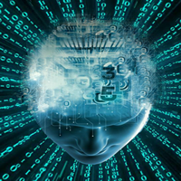

The Artificial Intelligence tutorial provides an introduction to AI which will help you to understand the concepts behind Artificial Intelligence. In this tutorial, we have also discussed various popular topics such as History of AI, applications of AI, deep learning, machine learning, natural language processing, Reinforcement learning, Q-learning, Intelligent agents, Various search algorithms, etc.

Our AI tutorial is prepared from an elementary level so you can easily understand the complete tutorial from basic concepts to the high-level concepts.

## What is Artificial Intelligence (AI)?

In today's world, technology is growing very fast, and we are getting in touch with different new technologies day by day.

Here, one of the booming technologies of computer science is Artificial Intelligence which is ready to create a new revolution in the world by making intelligent machines.The Artificial Intelligence is now all around us. It is currently working with a variety of subfields, ranging from general to specific, such as self-driving cars, playing chess, proving theorems, playing music, Painting, etc.

AI is one of the fascinating and universal fields of Computer science which has a great scope in future. AI holds a tendency to cause a machine to work as a human.

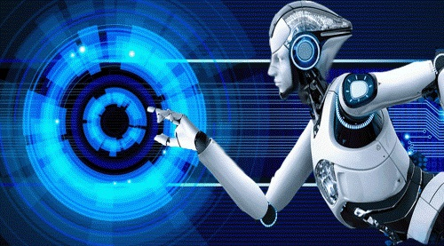

Artificial Intelligence is composed of two words **Artificial** and **Intelligence**, where Artificial defines *"man-made,"* and intelligence defines *"thinking power"*, hence AI means *"a man-made thinking power."*

So, we can define AI as:

"It is a branch of computer science by which we can create intelligent machines which can behave like a human, think like humans, and able to make decisions."

Artificial Intelligence exists when a machine can have human based skills such as learning, reasoning, and solving problems

With Artificial Intelligence you do not need to preprogram a machine to do some work, despite that you can create a machine with programmed algorithms which can work with own intelligence, and that is the awesomeness of AI.

It is believed that AI is not a new technology, and some people says that as per Greek myth, there were Mechanical men in early days which can work and behave like humans.

## Why Artificial Intelligence?

Before Learning about Artificial Intelligence, we should know that what is the importance of AI and why should we learn it. Following are some main reasons to learn about AI:

* With the help of AI, you can create such software or devices which can solve real-world problems very easily and with accuracy such as health issues, marketing, traffic issues, etc.
* With the help of AI, you can create your personal virtual Assistant, such as Cortana, Google Assistant, Siri, etc.
* With the help of AI, you can build such Robots which can work in an environment where survival of humans can be at risk.
* AI opens a path for other new technologies, new devices, and new Opportunities.

## Goals of Artificial Intelligence

Following are the main goals of Artificial Intelligence:

1. Replicate human intelligence
2. Solve Knowledge-intensive tasks
3. An intelligent connection of perception and action
4. Building a machine which can perform tasks that requires human intelligence such as:
   * Proving a theorem
   * Playing chess
   * Plan some surgical operation
   * Driving a car in traffic
5. Creating some system which can exhibit intelligent behavior, learn new things by itself, demonstrate, explain, and can advise to its user.

## What Comprises Artificial Intelligence?

Artificial Intelligence is not just a part of computer science even it's so vast and requires lots of other factors which can contribute to it. To create the AI first we should know that how intelligence is composed, so the Intelligence is an intangible part of our brain which is a combination of **Reasoning, learning, problem-solving perception, language understanding, etc**.

To achieve the above factors for a machine or software Artificial Intelligence requires the following discipline:

* Mathematics
* Biology
* Psychology
* Sociology
* Computer Science
* Neurons Study
* Statistics

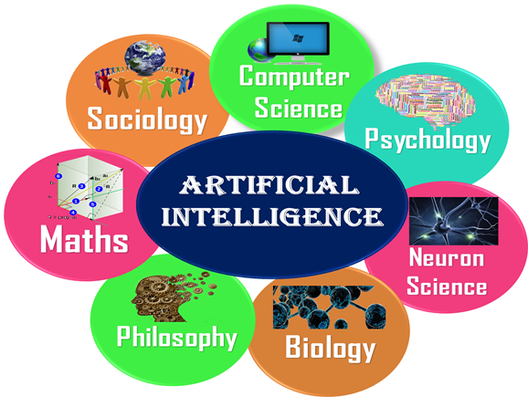

## Advantages of Artificial Intelligence

Following are some main advantages of Artificial Intelligence:

* **High Accuracy with less errors:** AI machines or systems are prone to less errors and high accuracy as it takes decisions as per pre-experience or information.
* **High-Speed:** AI systems can be of very high-speed and fast-decision making, because of that AI systems can beat a chess champion in the Chess game.
* **High reliability:** AI machines are highly reliable and can perform the same action multiple times with high accuracy.
* **Useful for risky areas:** AI machines can be helpful in situations such as defusing a bomb, exploring the ocean floor, where to employ a human can be risky.
* **Digital Assistant:** AI can be very useful to provide digital assistant to the users such as AI technology is currently used by various E-commerce websites to show the products as per customer requirement.
* **Useful as a public utility:** AI can be very useful for public utilities such as a self-driving car which can make our journey safer and hassle-free, facial recognition for security purpose, Natural language processing to communicate with the human in human-language, etc.

## Disadvantages of Artificial Intelligence

Every technology has some disadvantages, and thesame goes for Artificial intelligence. Being so advantageous technology still, it has some disadvantages which we need to keep in our mind while creating an AI system. Following are the disadvantages of AI:

* **High Cost:** The hardware and software requirement of AI is very costly as it requires lots of maintenance to meet current world requirements.
* **Can't think out of the box:** Even we are making smarter machines with AI, but still they cannot work out of the box, as the robot will only do that work for which they are trained, or programmed.
* **No feelings and emotions:** AI machines can be an outstanding performer, but still it does not have the feeling so it cannot make any kind of emotional attachment with human, and may sometime be harmful for users if the proper care is not taken.
* **Increase dependency on machines:** With the increment of technology, people are getting more dependent on devices and hence they are losing their mental capabilities.
* **No Original Creativity:** As humans are so creative and can imagine some new ideas but still AI machines cannot beat this power of human intelligence and cannot be creative and imaginative.

## Prerequisite

Before learning about Artificial Intelligence, you must have the fundamental knowledge of following so that you can understand the concepts easily:

* Any computer language such as C, C++, Java, Python, etc.(knowledge of Python will be an advantage)
* Knowledge of essential Mathematics such as derivatives, probability theory, etc.

## Audience

Our AI tutorial is designed specifically for beginners and also included some high-level concepts for professionals.

## Problems

We assure you that you will not find any difficulty while learning our AI tutorial. But if there any mistake, kindly post the problem in the contact form.